**LAB-4**

**AIM:**

Write a program to:

1. Implement backtracking algorithm for computing all possible solution of a N-Queen and also computing the number of backtracks.
2. Solve a sudoku problem and computing the number of backtracks.
3. Find all unique combinations of candidates (set of candidate numbers) such that the sum of candidates is equal to the target sum.

**EXPERIMENT:**

Backtracking is an algorithmic-technique for solving problems recursively by trying to build a solution incrementally, one piece at a time, removing those solutions that fail to satisfy the constraints of the problem at any point of time. Backtracking can be defined as a general algorithmic technique that considers searching every possible combination in order to solve a computational problem.

**OUTPUT:**

N-Queen problem:

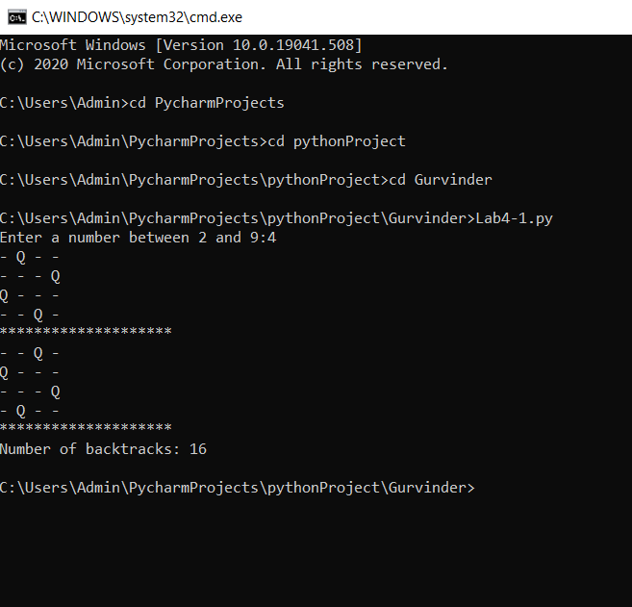

Suduko problem:

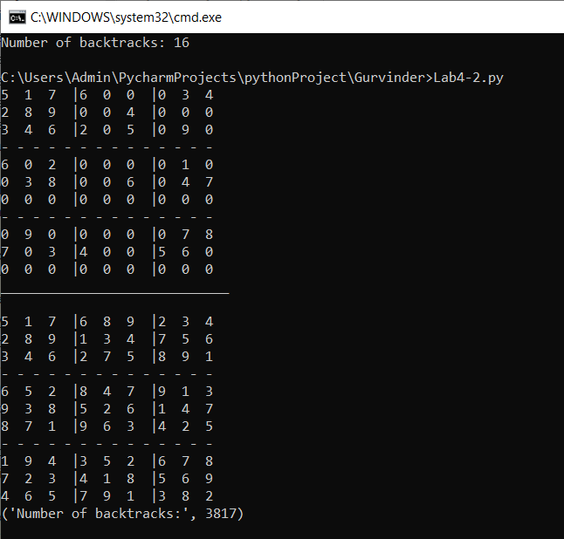

Combinational Sum problem:

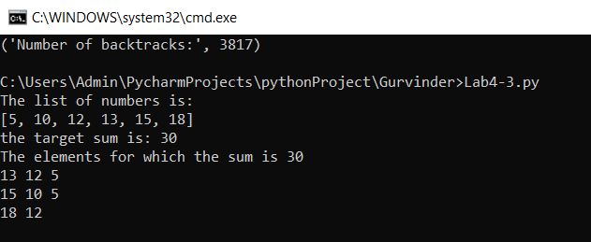

**CONCLUSION:**

The probleem statements have been solved and the backtracking algorithm was implemented and studied.

**Please find three (.py) files uploaded on the drive.